Fiat Currency
# Source: AI Source: Provided by: [Data Path: Persons Table -> ID Column: 1, Name_En Column: Motasem Essam] -> From: [ChatGPT] on [7/17/2026]





Fiat Currency is a type of currency whose value comes from government authority, legal recognition, and public trust, rather than from being directly backed by a physical commodity such as gold or silver.
Today, almost every national currency in the world is a fiat currency.

Definition
# Source: AI Source: Provided by: [Data Path: Persons Table -> ID Column: 1, Name_En Column: Motasem Essam] -> From: [ChatGPT] on [7/17/2026]
Fiat Currency is government-issued money that has value because it is declared legal tender and accepted by the public, rather than because it is directly convertible into a physical commodity.

Meaning of "Fiat"
# Source: AI Source: Provided by: [Data Path: Persons Table -> ID Column: 1, Name_En Column: Motasem Essam] -> From: [ChatGPT] on [7/17/2026]
The word fiat comes from Latin, meaning:
"Let it be done."
In economics, it means that the currency has value because the government officially declares it to be legal money.

How Fiat Currency Gets Its Value
# Source: AI Source: Provided by: [Data Path: Persons Table -> ID Column: 1, Name_En Column: Motasem Essam] -> From: [ChatGPT] on [7/17/2026]
Fiat currency derives its value from:
- Government recognition.
- Legal tender laws.
- Public confidence and acceptance.
- The strength and stability of the issuing country's economy.
It is not backed by gold, silver, or other physical commodities.

Characteristics of Fiat Currency
# Source: AI Source: Provided by: [Data Path: Persons Table -> ID Column: 1, Name_En Column: Motasem Essam] -> From: [ChatGPT] on [7/17/2026]
Fiat currency is:
- Issued by a government or central bank.
- Recognized as legal tender.
- Accepted for paying taxes and debts.
- Not directly redeemable for gold or silver.
- Used for everyday economic transactions.

Examples of Fiat Currencies
# Source: AI Source: Provided by: [Data Path: Persons Table -> ID Column: 1, Name_En Column: Motasem Essam] -> From: [ChatGPT] on [7/17/2026]
Most national currencies today are fiat currencies.
Examples include:
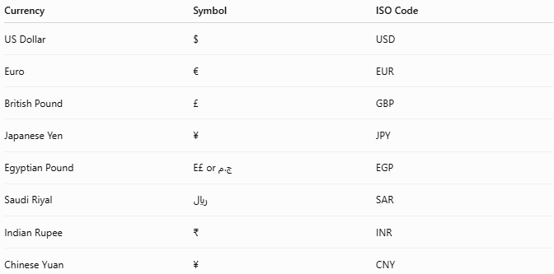
Currency | Symbol | ISO Code
US Dollar | $ | USD
Euro | € | EUR
British Pound | £ | GBP
Japanese Yen | ¥ | JPY
Egyptian Pound | E£ or ج.م | EGP
Saudi Riyal | ﷼ | SAR
Indian Rupee | ₹ | INR
Chinese Yuan | ¥ | CNY

Issuing Authority
# Source: AI Source: Provided by: [Data Path: Persons Table -> ID Column: 1, Name_En Column: Motasem Essam] -> From: [ChatGPT] on [7/17/2026]
Fiat currencies are usually issued by a central bank.
Examples:

Country/Region | Central Bank
United States | Federal Reserve
Eurozone | European Central Bank
United Kingdom | Bank of England
Egypt | Central Bank of Egypt
Japan | Bank of Japan

Legal Tender
# Source: AI Source: Provided by: [Data Path: Persons Table -> ID Column: 1, Name_En Column: Motasem Essam] -> From: [ChatGPT] on [7/17/2026]
Fiat currency is considered legal tender, meaning it must be accepted according to the laws of the issuing country for settling debts and making payments.

Historical Background
Historically, many currencies were backed by precious metals under systems such as the Gold Standard.
During the 20th century, most countries gradually abandoned commodity-backed money and adopted fiat currencies.
Today:
- Nearly all national currencies operate under a fiat monetary system.

Advantages
Fiat currency provides:
- Flexible monetary policy.
- Easier economic management.
- Efficient large-scale money supply.
- Convenient modern banking.
- Stable support for national economies.

Limitations
# Source: AI Source: Provided by: [Data Path: Persons Table -> ID Column: 1, Name_En Column: Motasem Essam] -> From: [ChatGPT] on [7/17/2026]
Fiat currency may experience:
- Inflation.
- Loss of purchasing power over time.
- Dependence on economic stability.
- Dependence on public confidence.
Poor monetary management can reduce the value of fiat currency.

Fiat Currency vs. Commodity Currency
# Source: AI Source: Provided by: [Data Path: Persons Table -> ID Column: 1, Name_En Column: Motasem Essam] -> From: [ChatGPT] on [7/17/2026]
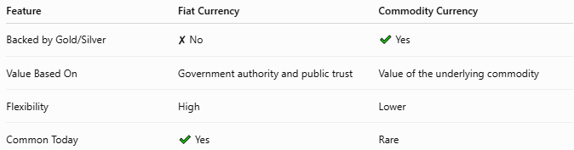
Feature | Fiat Currency | Commodity Currency
Backed by Gold/Silver | ✘ No | ✔ Yes
Value Based On | Government authority and public trust | Value of the underlying commodity
Flexibility | High | Lower
Common Today | ✔ Yes | Rare

Fiat Currency vs. Cryptocurrency
# Source: AI Source: Provided by: [Data Path: Persons Table -> ID Column: 1, Name_En Column: Motasem Essam] -> From: [ChatGPT] on [7/17/2026]

Feature | Fiat Currency | Cryptocurrency
Issued By | Government or central bank | Usually decentralized network
Legal Tender | Yes (within issuing country) | Varies by country
Physical Form | Paper, coins, and digital balances | Digital only
Regulation | Government regulated | Varies significantly

Applications
# Source: AI Source: Provided by: [Data Path: Persons Table -> ID Column: 1, Name_En Column: Motasem Essam] -> From: [ChatGPT] on [7/17/2026]
Fiat currencies are used for:
- Retail purchases
- Banking
- Salaries
- Taxes
- Investments
- International trade
- Government spending

Common Mistakes
# Source: AI Source: Provided by: [Data Path: Persons Table -> ID Column: 1, Name_En Column: Motasem Essam] -> From: [ChatGPT] on [7/17/2026]
- Believing fiat currency has no value because it is not backed by gold. Its value comes from legal recognition, economic activity, and public confidence.
- Confusing fiat currency with digital money. Digital money is a form in which fiat currency can exist electronically.
- Assuming all fiat currencies have equal purchasing power.

Interesting Facts
# Source: AI Source: Provided by: [Data Path: Persons Table -> ID Column: 1, Name_En Column: Motasem Essam] -> From: [ChatGPT] on [7/17/2026]
- Almost every country today uses a fiat currency.
- Fiat currencies may exist as:
  - Coins
  - Banknotes
  - Electronic bank balances
- The value of a fiat currency is influenced by factors such as inflation, interest rates, economic performance, and market confidence.

Key Points
# Source: AI Source: Provided by: [Data Path: Persons Table -> ID Column: 1, Name_En Column: Motasem Essam] -> From: [ChatGPT] on [7/17/2026]
- Fiat Currency is money issued by a government or central bank.
- It is not backed by a physical commodity like gold or silver.
- Its value depends on:
  - Government authority
  - Legal tender status
  - Public trust
  - Economic stability
- Nearly all modern national currencies are fiat currencies.
- Fiat currency supports modern banking, commerce, and monetary policy.

Conclusion
# Source: AI Source: Provided by: [Data Path: Persons Table -> ID Column: 1, Name_En Column: Motasem Essam] -> From: [ChatGPT] on [7/17/2026]
Fiat Currency is the dominant form of money used in the modern world. Rather than deriving its value from precious metals, it gains value through government recognition, legal tender status, public confidence, and the strength of the economy. Issued and managed by central banks, fiat currencies provide the flexibility needed for modern financial systems while supporting trade, banking, taxation, and everyday economic activity.

